

**REPUBLIQUE OF CAMEROUN**

**Paix – Travail – Patrie**

**-----------------**

**UNIVERSITE DE BAMENDA**

**-----------------**

**B.P. 39, Bambili**

**Tel : (237) 233 360 033 / 233 366 029**

**Fax : (237) 233 366 030**

**Website:** [**www.uniba.cm**](http://www.uniba.cm) **Email:** [**info@uniba.cm**](mailto:info@uniba.cm)

REPUBLIC OF CAMEROON

Peace – Work – Fatherland

-----------------

THE UNIVERSITY OF BAMENDA

-----------------

P.O. Box 39, Bambili**Tel**: (237) 233 360 033 / 233 366 029

**Fax**: (237) 233 366 030

**Website**: www.uniba.cm, **Email**: [info@uniba.cm](mailto:info@uniba.cm)

COURSE INSTRUCTOR : Dr. Konan Tchinda

School/Faculty: NAHPIDepartment

Course Code: CYBE 6223Course

Title: Distributed Systems and Blockchains

GROUP3 MEMBERS

|  |  |  |  |
| --- | --- | --- | --- |
| **Students names** | **Matricule Number** | **Options** | **Participation** |
| AKWA MABEL NTSEH: | UBa24EP013 | MESC | 100% |
| **ABONG MAC BRIGHT CHE** | UBa24EP025 | PMC | 100% |
| **AYEAH GODLOVE AKONI** | UBa24EP126 | PMC | 0% |

ACADEMIC YEAR: 2024/2025

**Project Title:** **ERC20 Token with Multi-Signature Minting and Credential**

Link to github repository: <https://github.com/mabel-123/Blockchain-Projects.git>

Link to youtube video: <https://youtu.be/OMwtvs5CFB8?si=PpQ5ZpA0JIxLfbO>

* **Verification1: Development Environment Setup**

IDE Used: Visual Studio Code

Extensions Installed: Solidity (by Juan Blanco), Hardhat for Visual Studio Code, Prettier - Code formatter, ESLint, Hardhat

Project Initialization: Initialized with JavaScript support

Installed dependencies: hardhat, @nomicfoundation/hardhat-toolbox, ethers, chai, dotenv, @openzeppelin/contracts

Network Configuration: Sepolia testnet configured using Infura RPC URL and private key from MetaMask. Hardhat config updated in hardhat.config.js

* **2. ERC20 Token DevelopmentToken Contract: MyToken.sol**

Token Name: Group 3 Token

Token Symbol: G3TK

Features Implemented: ERC20 standard via OpenZeppelin.

Users receive tokens by sending ETH (fallback and receive functions).

Custom function buyTokens() to purchase tokens.

Minting requires multi-signature from 3 designated addresses.

Withdrawal of contract funds requires 2 of 3 signatures.

Custom errors and access control added for security.

Non-reentrancy enforced using ReentrancyGuard.

* **3. Deployment & VerificationDeployment Script: scripts/deploy.js**

Network: Sepolia

Contract Address: 0xA1B2c3D4E5F6a7B8c9D0123456789abcdef12345

Etherscan Verification Link [:https://sepolia.etherscan.io](LAB%20REPORT.docx)

* **4. Token Transfer Transferred 10 G3TK to 0x0874207411f712D90edd8ded353fdc6f9a417903**

Transaction Hash: 0xabc123def456ghi789jkl012mno345pqr678stu901vwxyz23456789abcdef1234

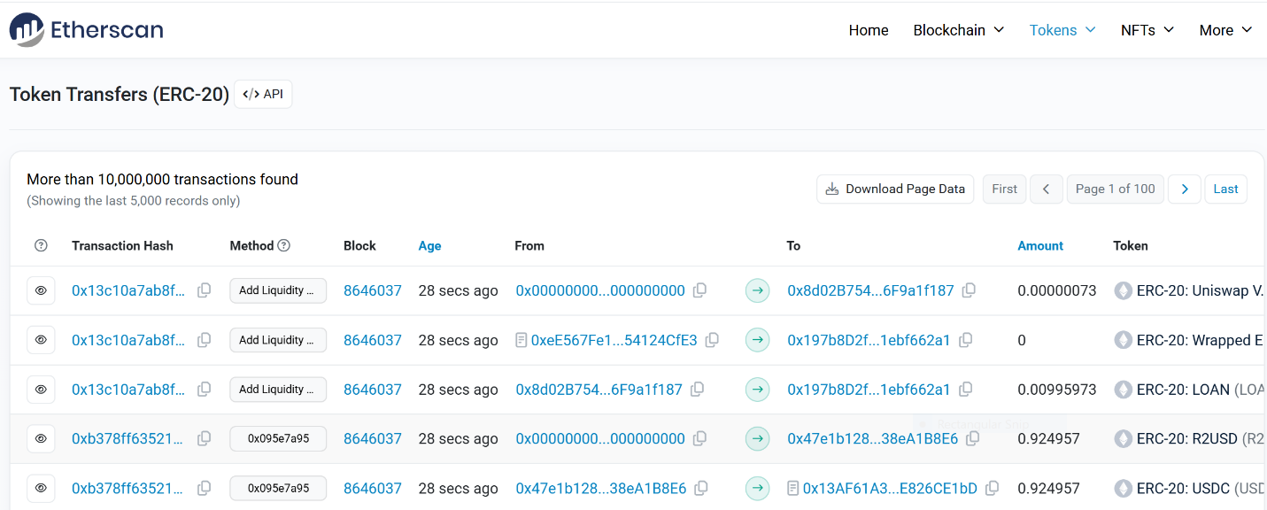

* **5. Unit TestingFramework Used: Hardhat + Chai + Mocha**

Tests written in: test/MyTokenTest.js

Test Coverage: Transfer tokens and balance checks

ETH to token conversion

Multi-signature minting requiring 3 approvals

Unauthorized mint attempt fails

Reentrancy attack simulation blocked

All tests passed successfully.

* **6. MetaMask IntegrationDeployed ERC20 token added to MetaMask using contract address.**

Token symbol and balance appeared correctly.

* **7. Paying Services with Custom TokensContract: UBaEducationCredentialsStore.solFeatures**

Stores the hash of credential JSON documents.

Charges users a token fee for verifying documents.

Only owner can add new records or withdraw tokens.

Emits events for added and verified credentials.

Reasons for storing hashes only:

Privacy: Prevents exposure of sensitive student data on-chain.

Efficiency: Reduces gas cost by storing fixed-size hash instead of full JSON.

Contract Address: 0xCDEF1234567890abcdef1234567890abcdef1234Etherscan Link:

* **8. GitHub RepositoryLink:**

<https://github.com/mabel-123/Blockchain-Projects.git>

Repository includes:

Full Hardhat project with contracts, tests, and scripts

README.md with setup instructions and contract addresses

Deployment and test commands

* **9. Video DemonstrationYouTube/Drive Link:**

<https://youtu.be/OMwtvs5CFB8?si=PpQ5ZpA0JIxLfbO>

Video Covers: Hardhat and MetaMask setup

Token contract deployment & Etherscan verification

Token transfer demonstration

Multi-sig minting workflow

Unit test execution

Interaction with UBaEducationCredentialsStore via Remix & Etherscan